Heikin-Ashi: The Structural Trade-Off Behind Smooth Trends
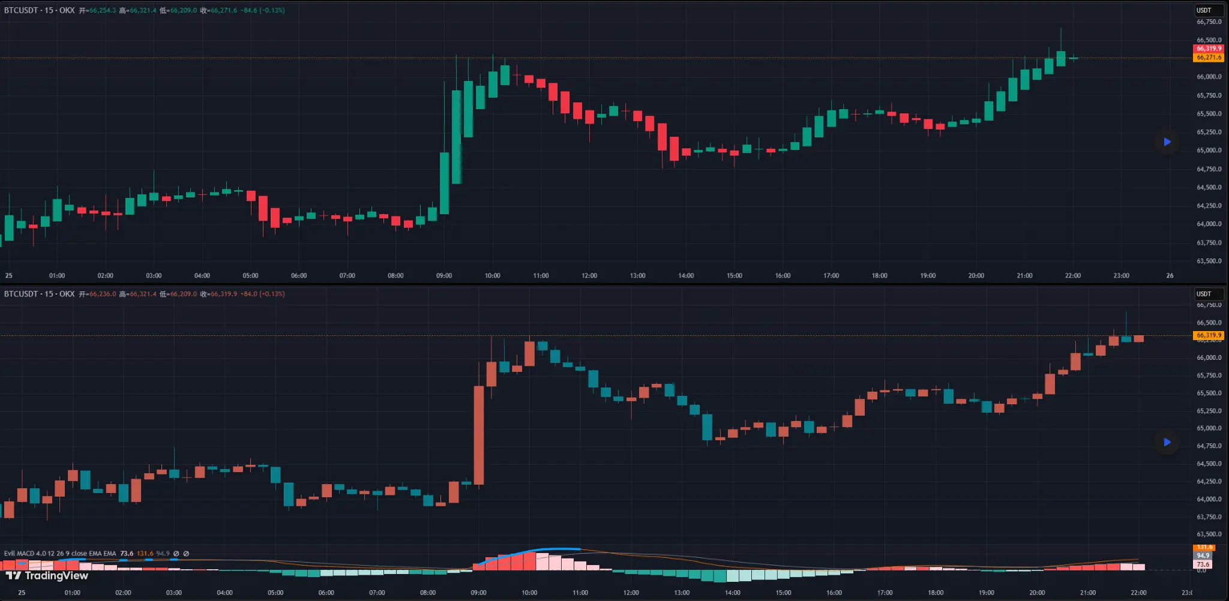
Heikin-Ashi (Top) vs Regular Candlestick (Bottom)
In the charting community, Heikin-Ashi has long been a debated tool.
Many traders experience the same reaction the first time they switch to a Heikin-Ashi chart:
trends look cleaner, colors appear more consistent, and market noise seems reduced.
The chart feels more “logical.”
But an important question follows:
Is that smoothness coming from the market itself — or from mathematical processing?
Understanding this distinction is more important than simply asking whether the tool is “good” or “bad.”
1. What Does Heikin-Ashi Actually Do?
A standard candlestick chart displays raw price data:
Open, High, Low, Close.
Heikin-Ashi does not plot these values directly. Instead, it recalculates them.
Its core formulas are:
1) Close (HA Close) = (Open + High + Low + Close) / 4
2) Open (HA Open) = (Previous HA Open + Previous HA Close) / 2
3) High (HA High) = max(High, HA Open, HA Close)
4) Low (HA Low) = min(Low, HA Open, HA Close)
From these formulas, we can see that Heikin-Ashi is fundamentally a smoothing mechanism.
By introducing averaging and previous values, it reduces the visual intensity of short-term fluctuations.
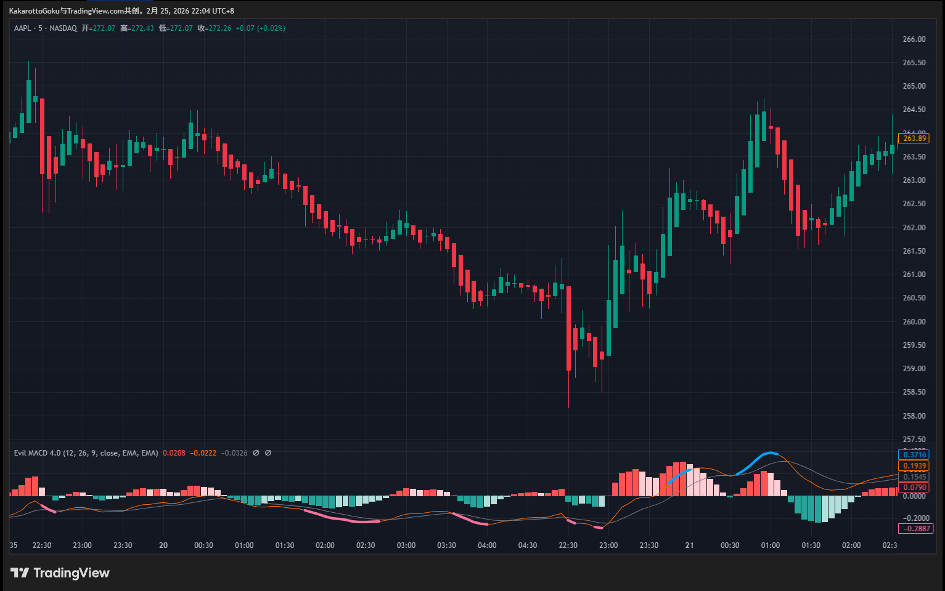
AAPL Regular Candlestick Chart
That is precisely why it appears more stable.
2. Why Does It Work Well in Trending Markets?
In strong directional markets, price already exhibits persistence.
Smoothing in this context can:
- Reduce frequent color flips
- Make trend legs appear clearer
- Extend sequences of same-colored candles
For swing traders or trend-following systems, this can help reduce noise and emotional overreaction.
In such environments, Heikin-Ashi can serve as a useful visual filter.
3. What Is the Trade-Off?
Every smoothing method comes with a cost.
1️⃣ The Price Is Not the Executable Price
Heikin-Ashi values are calculated — not traded.
When a color change occurs, the signal is based on computed prices rather than actual transaction prices.
During volatile periods, the gap between HA values and real market prices can widen.
For traders who rely on precise entries, this distinction matters.
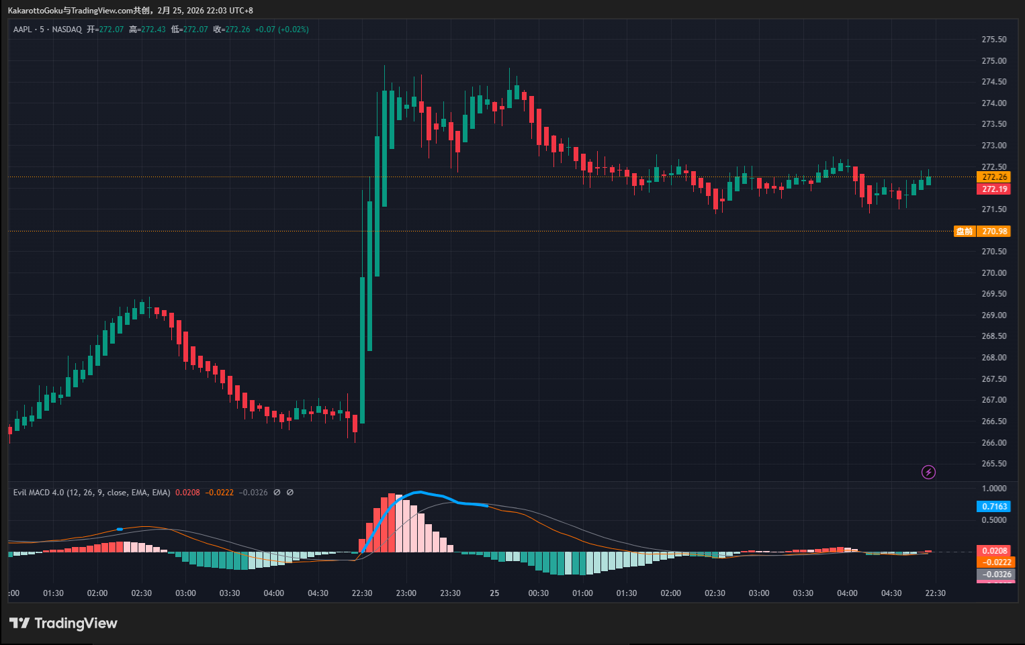
AAPL Heikin-Ashi Chart
2️⃣ Lag Is Structurally Built-In
Because each candle incorporates data from the previous one, lag is unavoidable.
In fast reversals, the real market may have already moved significantly before the HA candle changes color.
3️⃣ Certain Price Behaviors Are Softened
Gaps, extreme wicks, and sharp intrabar reversals may be partially smoothed out.
If your trading logic depends on detailed price behavior — such as wick rejection or gap momentum — Heikin-Ashi may reduce the informational granularity you rely on.
4. Suitability Matters More Than Judgment
Heikin-Ashi is not a “wrong” tool. The real issue is alignment.
If your strategy focuses on:
- Capturing trend continuation
- Holding positions longer
- Reducing frequent entries and exits
Then Heikin-Ashi may serve as a helpful visual aid.
But if your edge depends on:
- Capturing short-term volatility
- Precise timing
- Reading subtle structural shifts
Then applying a smoothing algorithm to your primary chart may conflict with your execution logic.
5. A Balanced Approach
Some traders choose to:
- Use Heikin-Ashi to assess directional bias
- Use standard candlesticks for entry and risk management
This separation of roles can provide clarity without sacrificing execution precision.
There is no “perfect” chart type.
Any tool that smooths price is making a trade-off between noise reduction and information detail.
The key question is not: "Is this tool good?" But rather: "Does it align with my trading logic?"
In chart analysis, understanding how data is constructed is often more valuable than adding another indicator.

